Entity Resolution in NLRB Data
Keywords: Union, Entity Resolution, Clustering, Word Embeddings, LLMs

Extended Abstract
Union formation in the US is unique. Unlike in many other countries, unions do not form at the national, industry-sector, or firm level, but at the level of individual worker units within an establishment. For example, at a specific Starbucks branch, the counter staff and waitstaff may decide to form a union, while the dishwashers may choose not to join. Furthermore, the outcome of workers' efforts to establish a union is uncertain. Workers must demonstrate, through a secret majority vote or an open election, that the majority of the unit supports the union; even then, no law compels employers to recognize the union, only to enter negotiations. A union organizing drive is a long and complex endeavor whose success is neither guaranteed nor determined by a single factor.

The National Labor Relations Board (NLRB) is a government agency with quasi-judicial authority that oversees union representation processes and investigates violations of collective bargaining law. The NLRB maintains two large databases. The first concerns representation cases (R Cases), documenting units' decisions to organize and, when needed, hold an election to choose a representative union, along with information about participants, vote shares, and outcomes. The second records unfair labor practice (ULP) claims (C Cases), documenting the participants, specific claims filed, and their resolution. The NLRB's filing systems have changed over the years and are available today in various formats, covering cases from the 1960s to the present.

The uniqueness of union formation in the US, combined with the NLRB's comprehensive databases, creates a rich research landscape. Prior research has addressed issues such as union spillover effects (Holmes, 2006), the impact of ULP violations on unionization success (Ferguson, 2008), the influence of union density on wage inequality (Kristal, 2023), and the effect of different legislative contexts on ULP filing (Haskett, 2024).

Research based on NLRB data faces a significant challenge when investigating connections across cases: the official files do not include a consistent identifier for the establishment or firm involved in each case. Thus, one cannot automatically link a ULP claim documented as a C Case filed during a union organizing drive to the relevant R Case, nor relate different R Cases that occurred at different establishments of the same firm. The NLRB records the name of the company involved, but because these are entered in free-text fields, the same company may appear differently due to phonetic spellings, reordered or abbreviated terms, nicknames, and other inconsistencies.

The lack of standardization in company names could be mitigated through entity resolution (ER), a data quality task aimed at identifying cases where different records refer to the same real-world entity (Christophides et al., 2020). Researchers have employed various methods to connect R Cases and C Cases. Earlier studies relied on manual matching for a sample of cases (Ferguson, 2008), while more recent work employs algorithms that compute string similarity (Lee & Mas, 2012; Zhang, 2025). In this approach, the similarity between two names is computed as the number of character changes required to transform one string into the other; pairs with similarity above a given threshold are considered matches. However, this method is limited because it relies solely on spelling while ignoring semantic content. For example, "USPS" and "United States Postal Service" would receive a low similarity score, incorrectly suggesting they refer to different entities.

To address this limitation, we propose using modern text analysis techniques. Our approach follows the LLM-CER (LLM-powered Clustering-based ER) framework presented by Fu et al. (2025), which leverages large language models to directly group records referring to the same entity. Using LLMs for clustering exploits their zero-shot learning capabilities (Kojima et al., 2022), enabling clustering of the NLRB's massive and unique dataset without the need to create a training set.

Our aim is to cluster company names and use the results as a reference to identify firms appearing across the data files. Subsequently, we will use geographic information, such as state and city, to identify unique establishments within firms.

We propose clustering company names appearing in NLRB data in three stages:

(1) Data Preprocessing: We extract relevant company information from the R Cases and C Cases databases across three NLRB filing systems—CHIPS (1984–1999), CATS (2000–2011), and NxGen (2012–2024). This yields a list of 463,344 string variations of American company names. The list then undergoes preprocessing: it is converted to lowercase, and stop words, punctuation, extra spaces, and irrelevant numeric characters are removed, resulting in 334,276 unique names.

(2) Blocking: Using Locality-Sensitive Hashing (LSH), we partition the search space into "blocks" of records deemed similar based on word-embedding cosine similarity. This reduces the number of pairwise comparisons in the subsequent stage (Azzalini et al., 2021).

(3) Hierarchical Clustering Using LLMs: In this stage, we use the LLM to cluster company names that refer to the same entity. Because the LLM cannot process arbitrarily large input sets, we divide each block into smaller record sets and use the LLM's output to incrementally merge them into stable clusters. At each level, the algorithm selects a representative name for each emerging cluster and passes it to the next level for further merging. The pipeline for generating record sets of optimal size and word order, and merging them hierarchically into stable clusters, follows the guidelines in Fu et al. (2025). See Figure 1 for an illustration of the merging process.

To validate our approach, we evaluate the clustering method on the task of linking R Cases to C Cases, comparing it against traditional fuzzy matching methods based on spelling similarity. Prior research shows that specific types of ULP charges are filed around union elections (McCammon, 2001). This allows us to filter the data to narrow time windows during which ULP cases are expected to be connected to R Cases occurring at the same establishment, and then apply both methods to identify potential matches. By examining cases in which our clustering disagrees with spelling-similarity matches, we can assess the strengths and weaknesses of both methods. If our approach yields improvements, it could advance NLRB data analysis by enabling firm-level aggregation, thereby opening new avenues for research.

References

Azzalini, F., Jin, S., Renzi, M., & Tanca, L. (2021). Blocking techniques for entity linkage: A semantics-based approach. Data Science and Engineering, 6(1), 20-38.

Christophides, V., Efthymiou, V., Palpanas, T., Papadakis, G., & Stefanidis, K. (2020). An overview of end-to-end entity resolution for big data. ACM Computing Surveys (CSUR), 53(6), 1-42.

Ferguson, J. P. (2008). The eyes of the needles: A sequential model of union organizing drives, 1999–2004. ILR Review, 62(1), 3-21.

Fu, J., Tang, H., Khan, A., Mehrotra, S., Ke, X., & Gao, Y. (2025). In-context clustering-based entity resolution with large language models: A design space exploration. Proceedings of the ACM on Management of Data, 3(4), 1-28.

Haskett, B. (2024). The Effect of Right-to-Work on Unfair Labor Practice Charges: Synthetic Control Evidence From Indiana and Michigan. Labor studies journal, 49(2), 115-134.

Holmes, T. J. (2006). Geographic spillover of unionism.

Kojima, T., Gu, S. S., Reid, M., Matsuo, Y., & Iwasawa, Y. (2022). Large language models are zero-shot reasoners. Advances in neural information processing systems, 35, 22199-22213.

Kristal, T. (2023). What can unions do? An impact estimate for an increase in the US Private-sector unionization rate on Workers’ earnings. Work and Occupations, 50(3), 400-411.

Lee, D. S., & Mas, A. (2012). Long-run impacts of unions on firms: New evidence from financial markets, 1961–1999. The Quarterly Journal of Economics, 127(1), 333-378.

McCammon, H. J. (2001). Labor's legal mobilization: Why and when do workers file unfair labor practices?. Work and Occupations, 28(2), 143-175.

Zhang, Y. (2025). Managerial incentives and earnings management: Insights from union certification elections. European Financial Management, 31(2), 841-875.
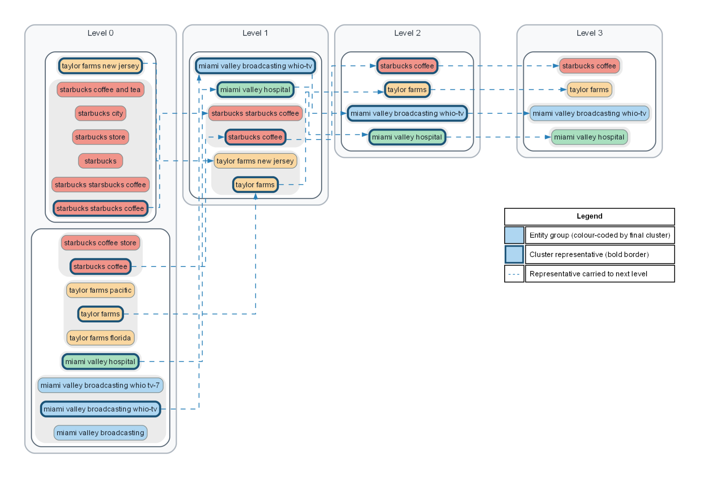

Figure 1. Illustration of the hierarchical clustering process applied to a block containing name variations of four companies. At each level, uniquely ordered record sets are sent to the LLM for clustering. The algorithm then selects a representative name for each emerging cluster and passes it to the next level. This process repeats until convergence.

